- How to Upload Photos on the Web
Step 1: Click the Photos icon
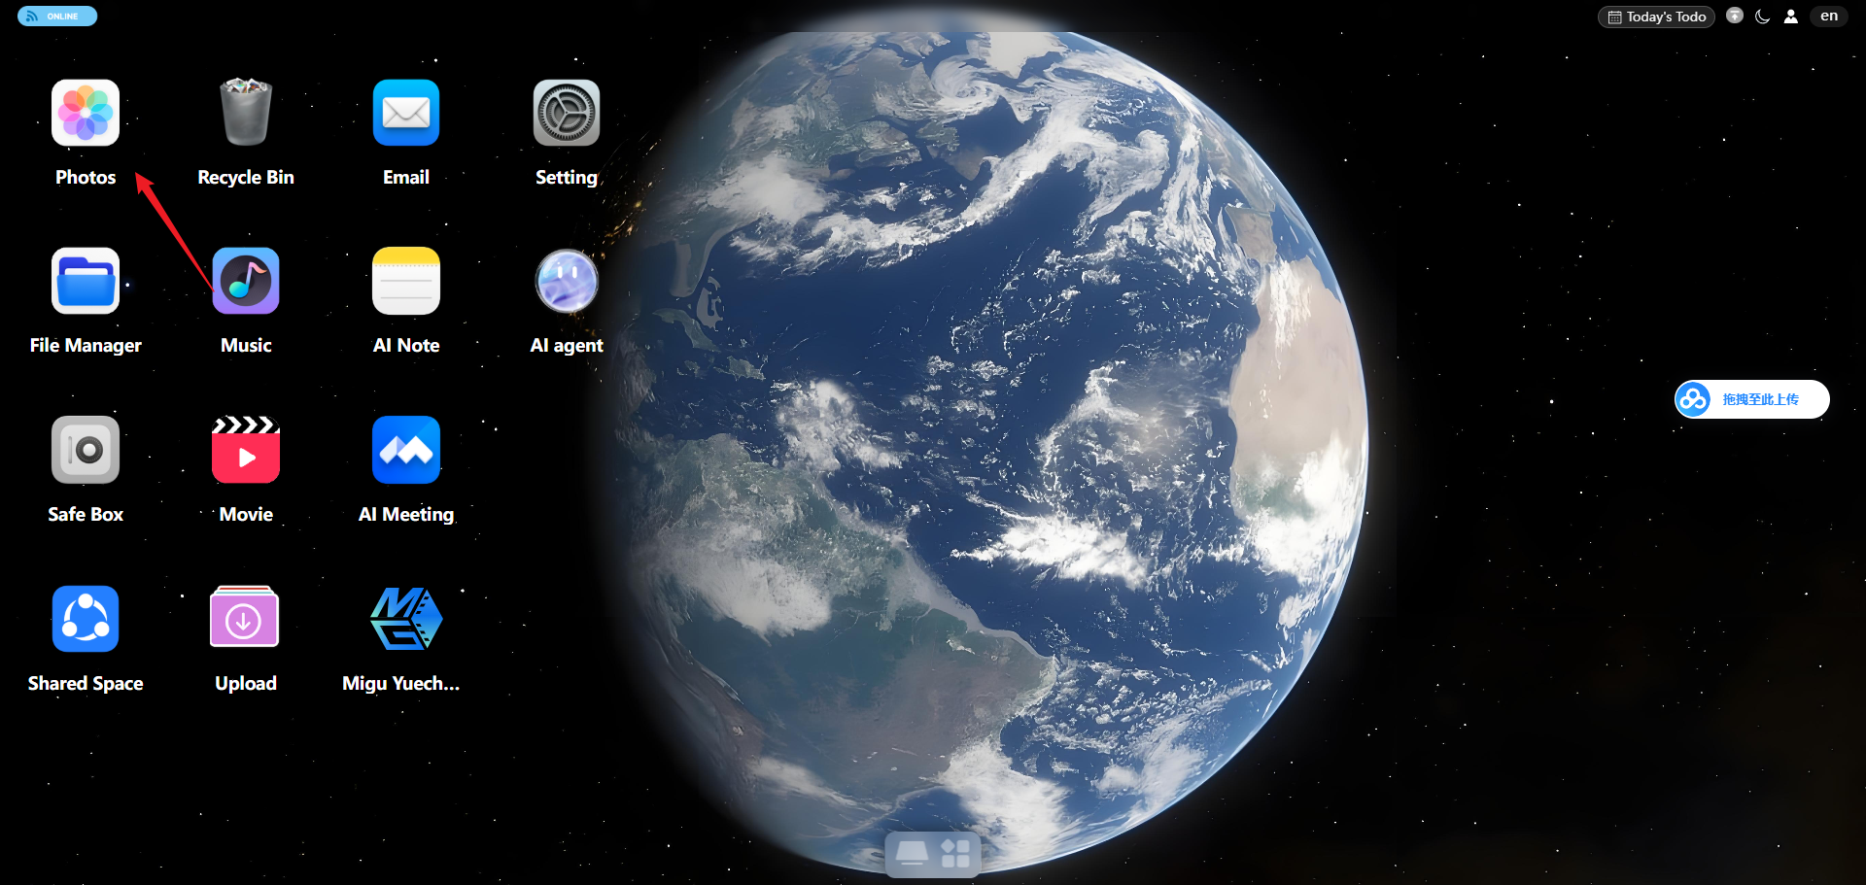
Step 2: Click the Upload File button in the lower-left corner to upload files or folders.

Step 3: After uploading, you can view the photos on the Album page.

