How to Edit Person Info on the Web
Step 1: Go to the Photos entry
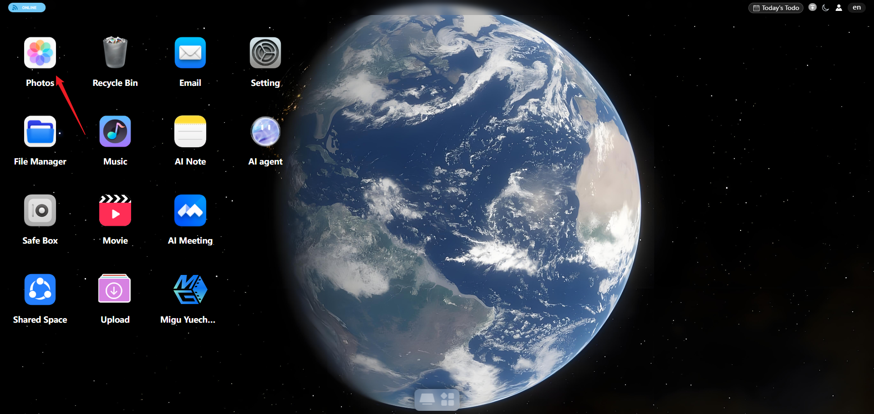
Step 2: Go to the People section of the Album. Drag the white slider below left or right to browse.
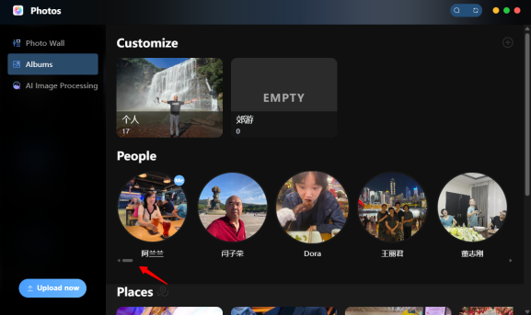
Step 3: Select the person’s avatar, right-click → Edit Portrait, and then fill in the name, birthday, gender, and other information.
