How to Create an AI Note on the Web
- Open the “AI Note” app from the desktop.
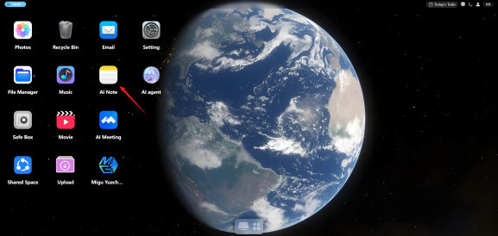
- Click “Add Note” in the lower-left corner to open the new note page.
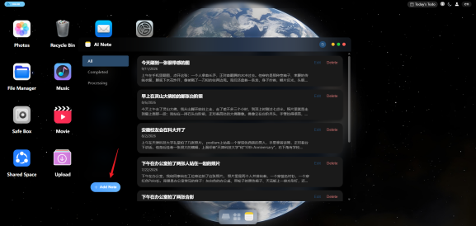
- Upload “Photos” as needed and fill in the “Prompt”.
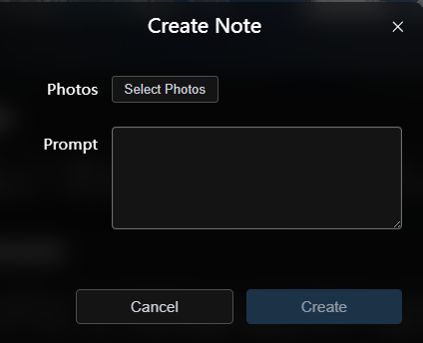
- Click “Create” and wait for the AI to generate the note.
- After the note is generated, you can view, edit, or delete it.
