How to Use the Safe on the Web
Safe features: The Safe provides a private storage space with independent encryption on your device, with the following core features: 1. Independent password system: You can set your own access password, which is isolated from the device system password, forming a double line of security. 2. Encrypted data storage: Files stored in the Safe are encrypted and can only be decrypted and viewed after verification. 3. Privacy isolation: Data in the Safe is isolated from the normal file system. Even if someone else gains access to the device, they cannot view, read, or export anything in the Safe without passing password verification, fully protecting your data privacy.
- Open the app: Click the Safe icon on the desktop.
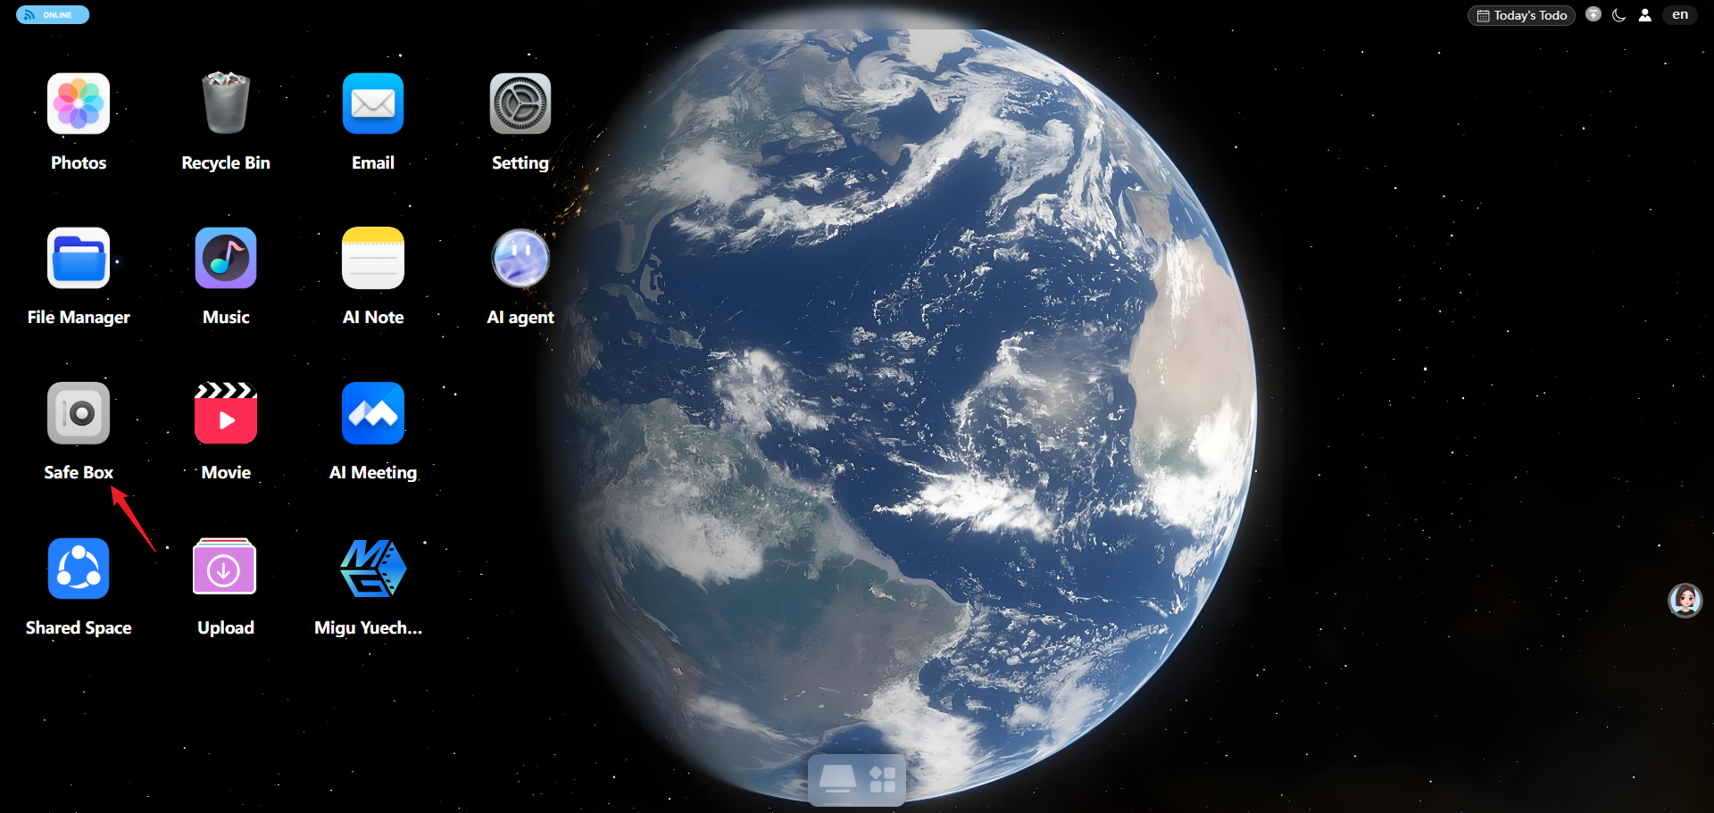
- Enter the 6-digit Safe password.
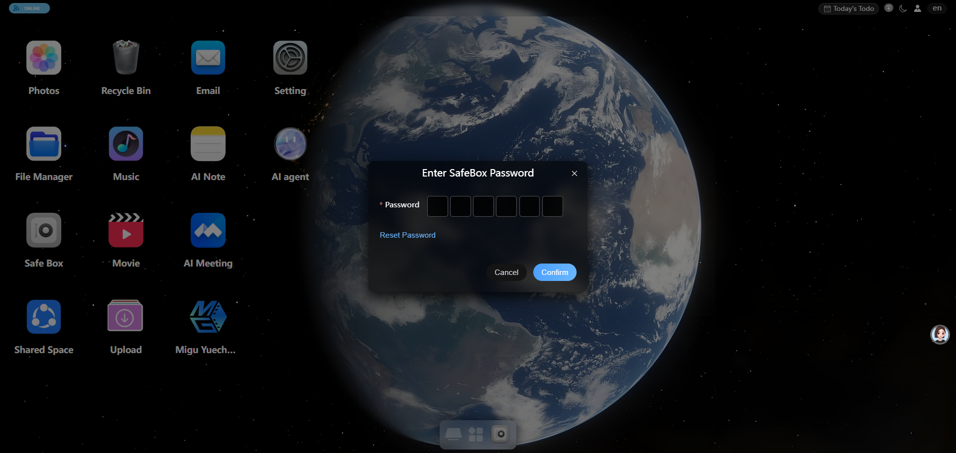
- After entering it, you enter the Safe screen; upload files from the upper-right corner.
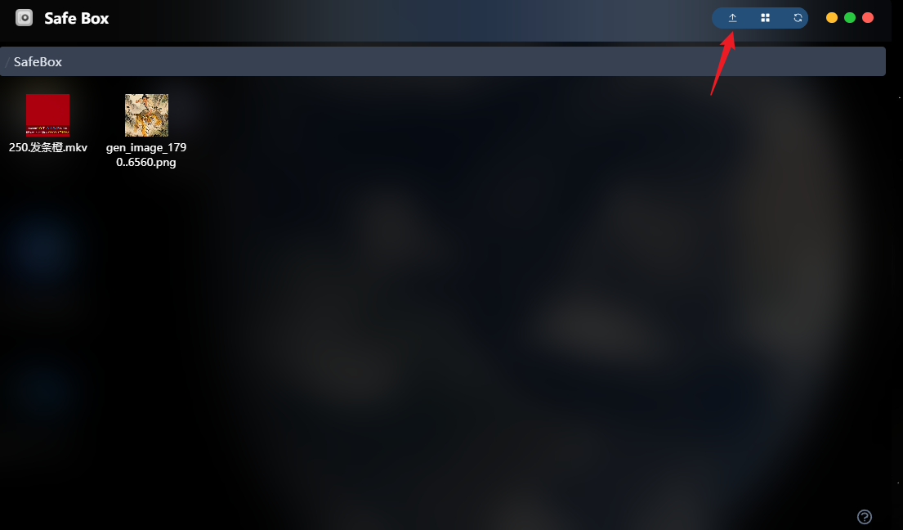
- After uploading, the uploaded files are isolated from other files and can only be viewed inside the Safe.

