How to Upload Movies on the Web
Step 1: Click the Movies icon.
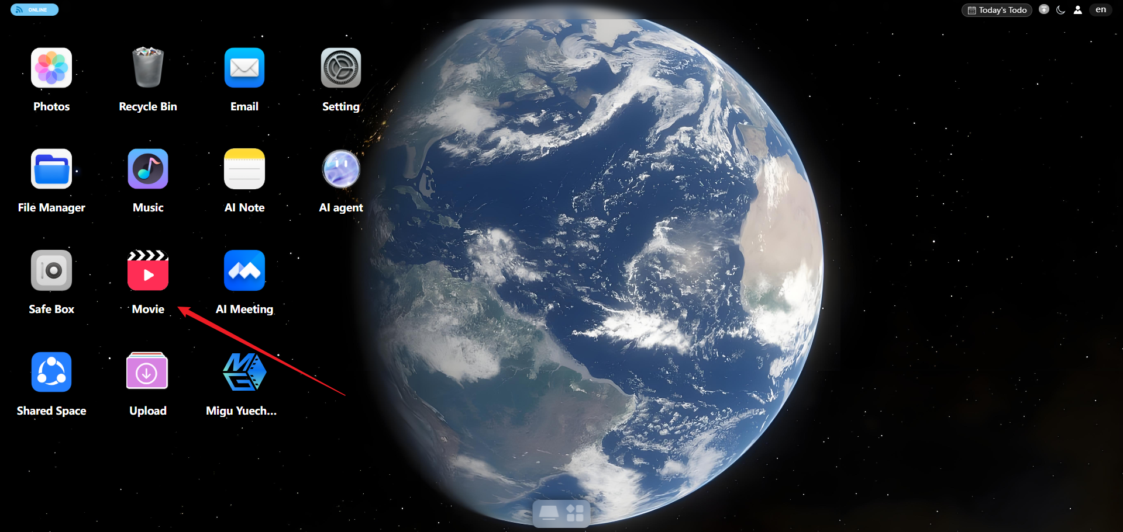
Step 2: Click the Upload File button in the upper-right corner to upload files or folders.
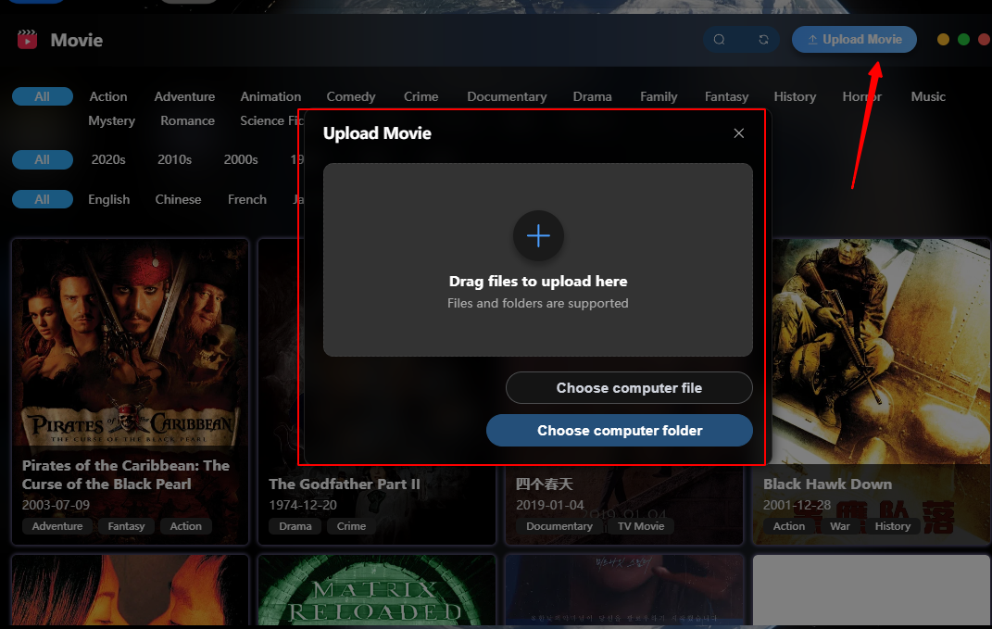
Step 3: After uploading, the upload progress is shown on the right side of the page.
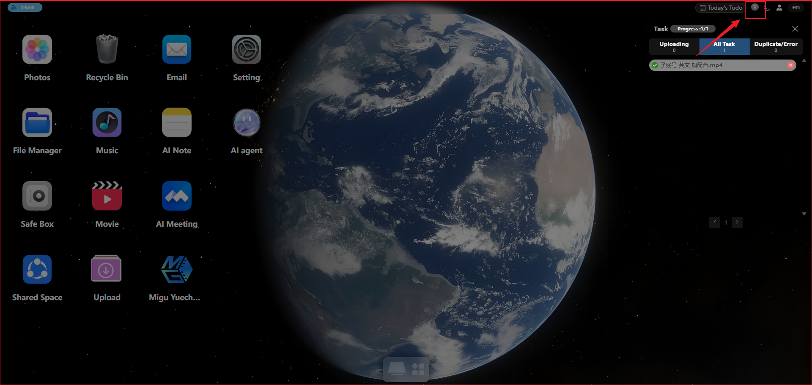
Step 4: When the progress is complete, you can view the uploaded movies on the Movies page.
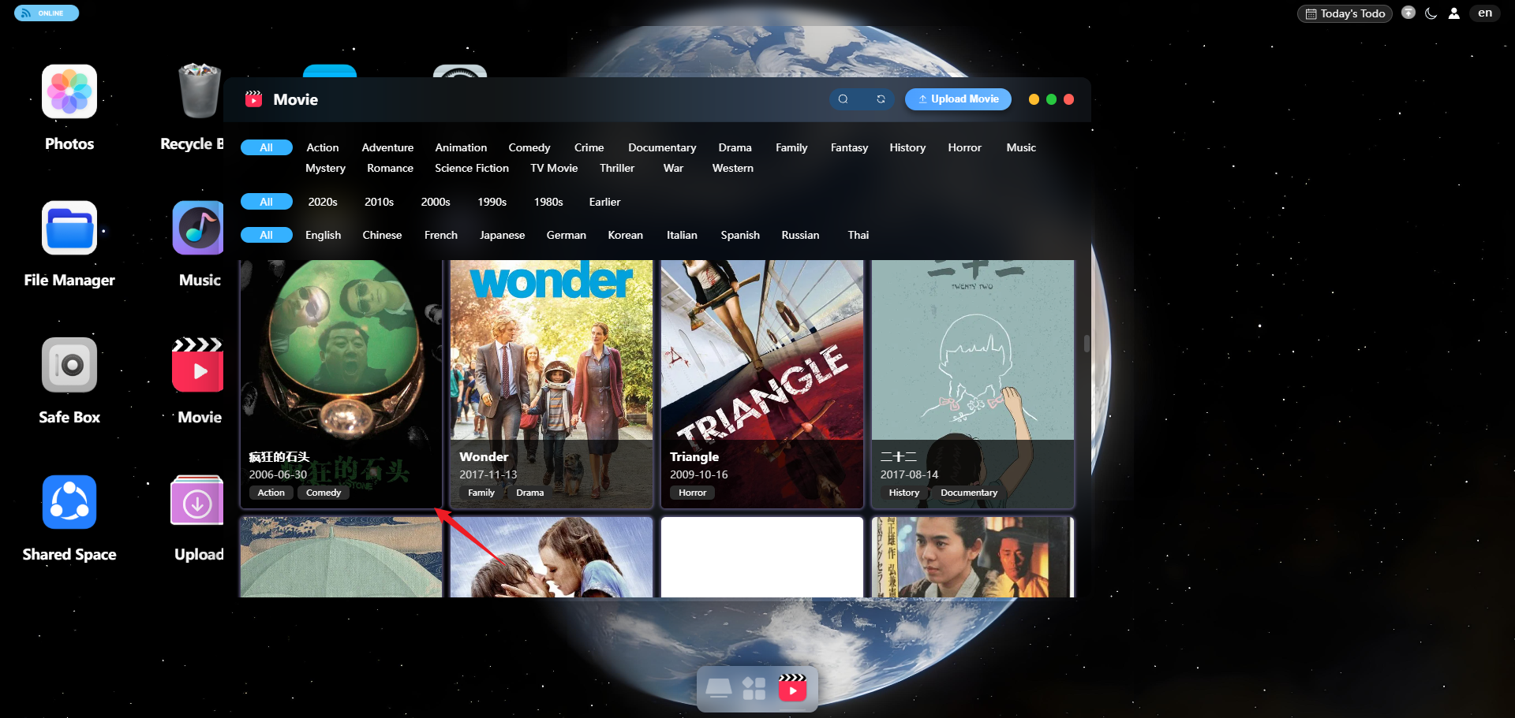
Note: Supported file formats: mp4, mov, avi, mkv, wmv, flv, webm, m4v, 3gp, ts, rmvb, rm.

