Browser P2P SDK Plugin Download Guide

Windows System:
- Google Chrome Installation Steps
Step 1: Open Google Chrome and visit the WITHBOX official website: web.ainest-tec.com. If the “Connection lost. Reconnecting...” message appears, click logout; if it does not appear, go to Step 2.
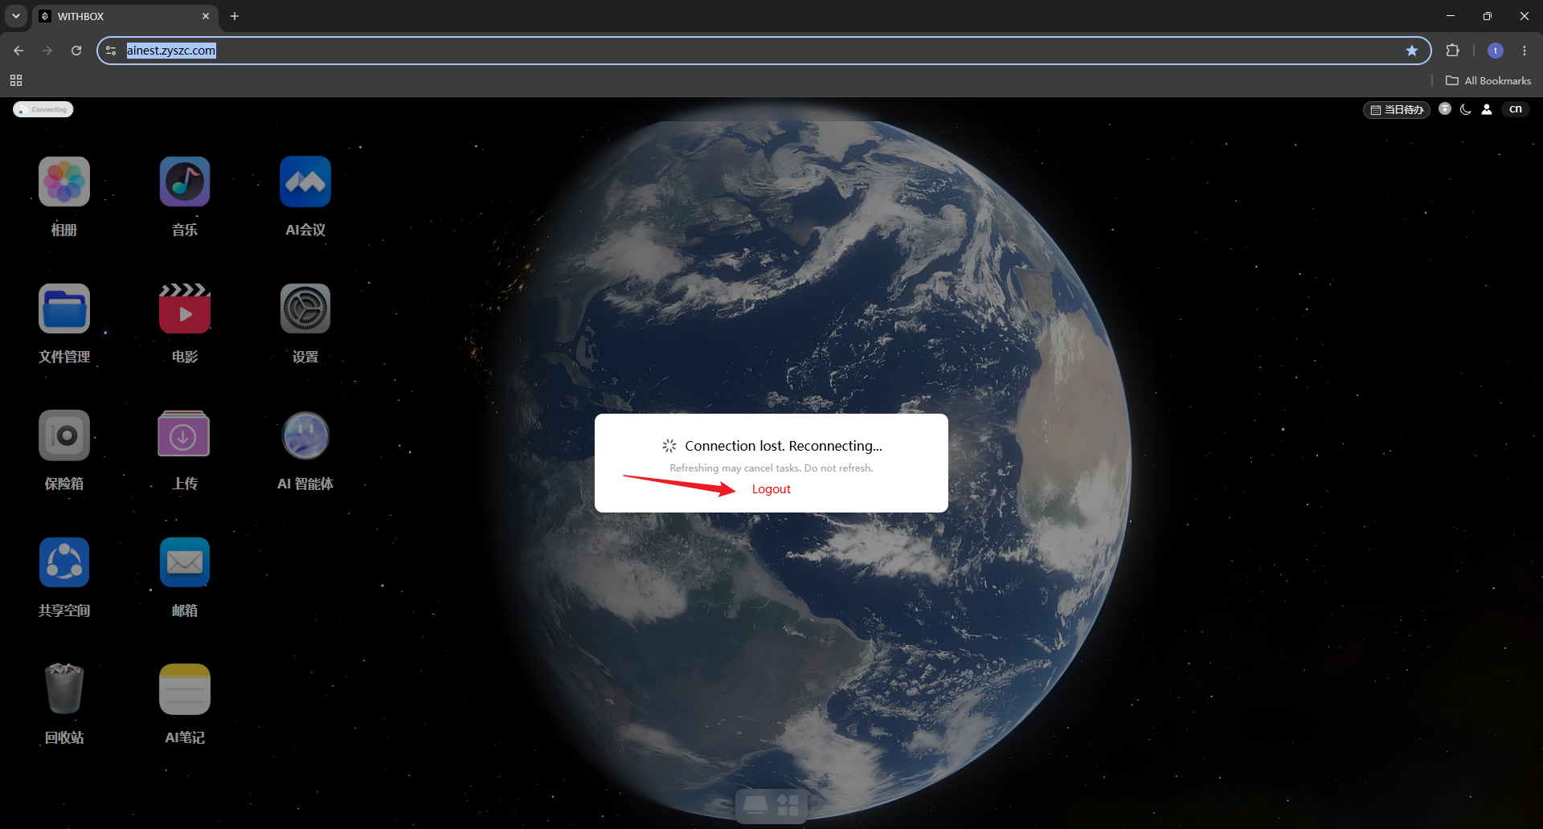
Step 2: An “SDK missing” prompt appears. Click Download in the pop-up to get the P2P SDK installer package (WITHBOX-P2P-control-Installer).
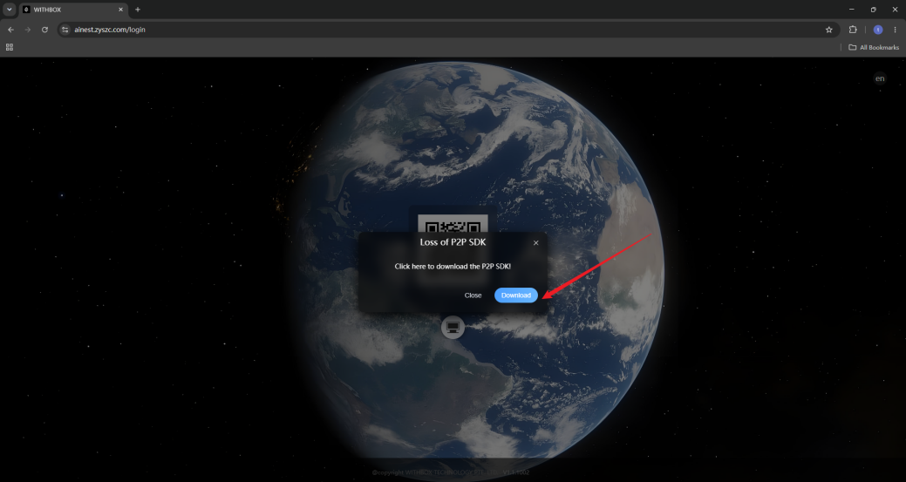
Step 3: After the download completes, click the installer file at the top of the browser or in the download list to start the installation wizard.
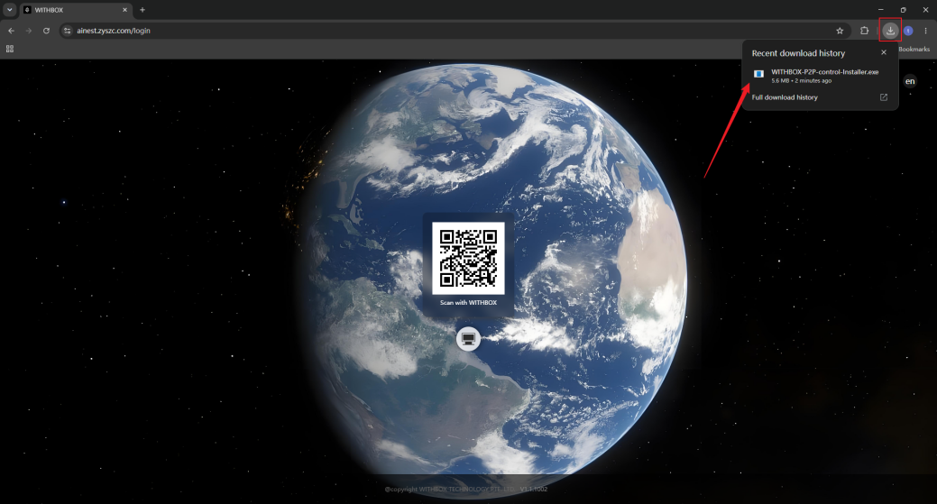
Step 4: Keep clicking Next as prompted by the wizard and wait for the progress to finish. When installation is complete, click Close to exit the installer.
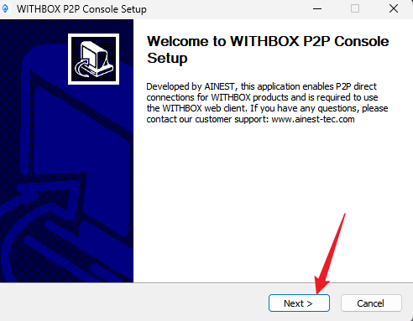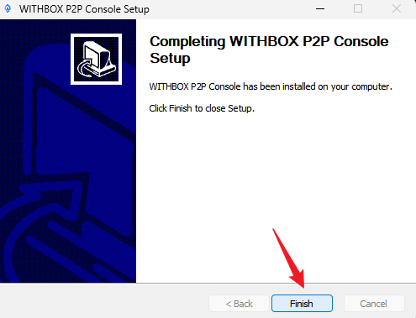

Step 5: Find the plugin icon (WITHBOX P2P Console) on your desktop and double-click it to launch the connection.

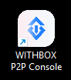

Step 6: Return to the WITHBOX web page and refresh it; the login QR code will appear and the installation is complete.

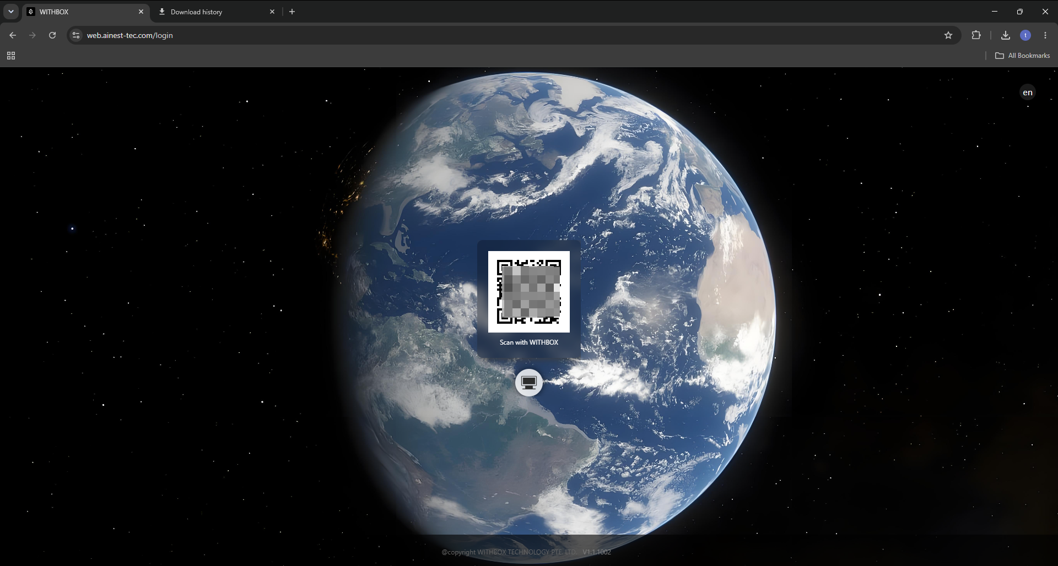
Note: If the “Windows protected your PC” prompt appears, click “More info” → “Run anyway” to continue the plugin installation (see the figure below).
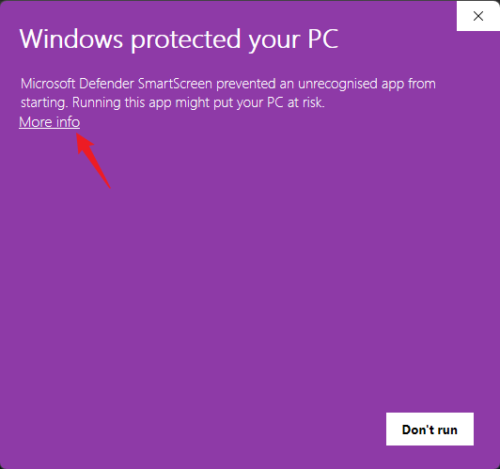
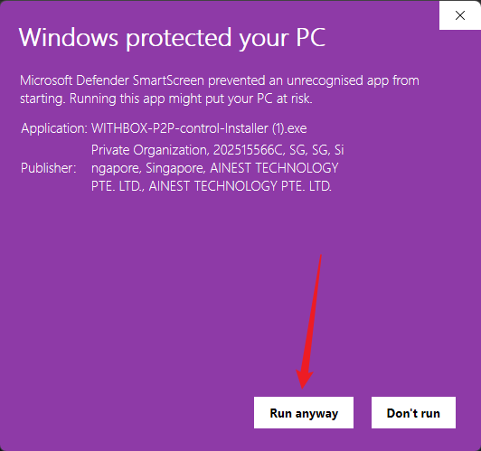
- Microsoft Edge Installation Steps
Step 1: Open Microsoft Edge and visit the WITHBOX official website: web.ainest-tec.com. If the “Connection lost. Reconnecting...” message appears, click logout; if it does not appear, go to Step 2.
Step 2: An “SDK missing” prompt appears. Click Download in the pop-up to get the P2P SDK installer package (WITHBOX-P2P-control-Installer).
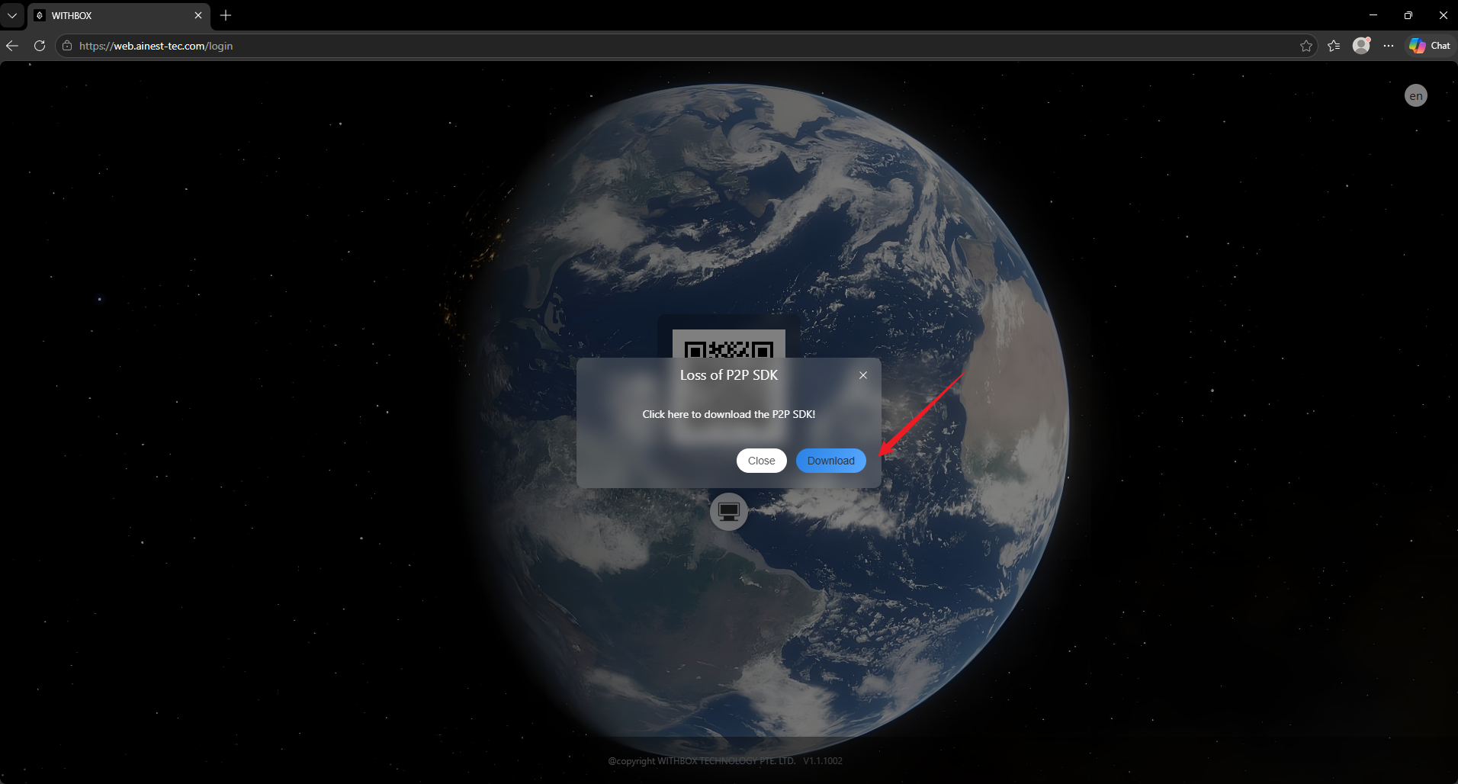

Step 3: After the download completes, click the installer file at the top of the browser or in the download list to start the installation wizard. (A warning may appear here; just follow the note below.)
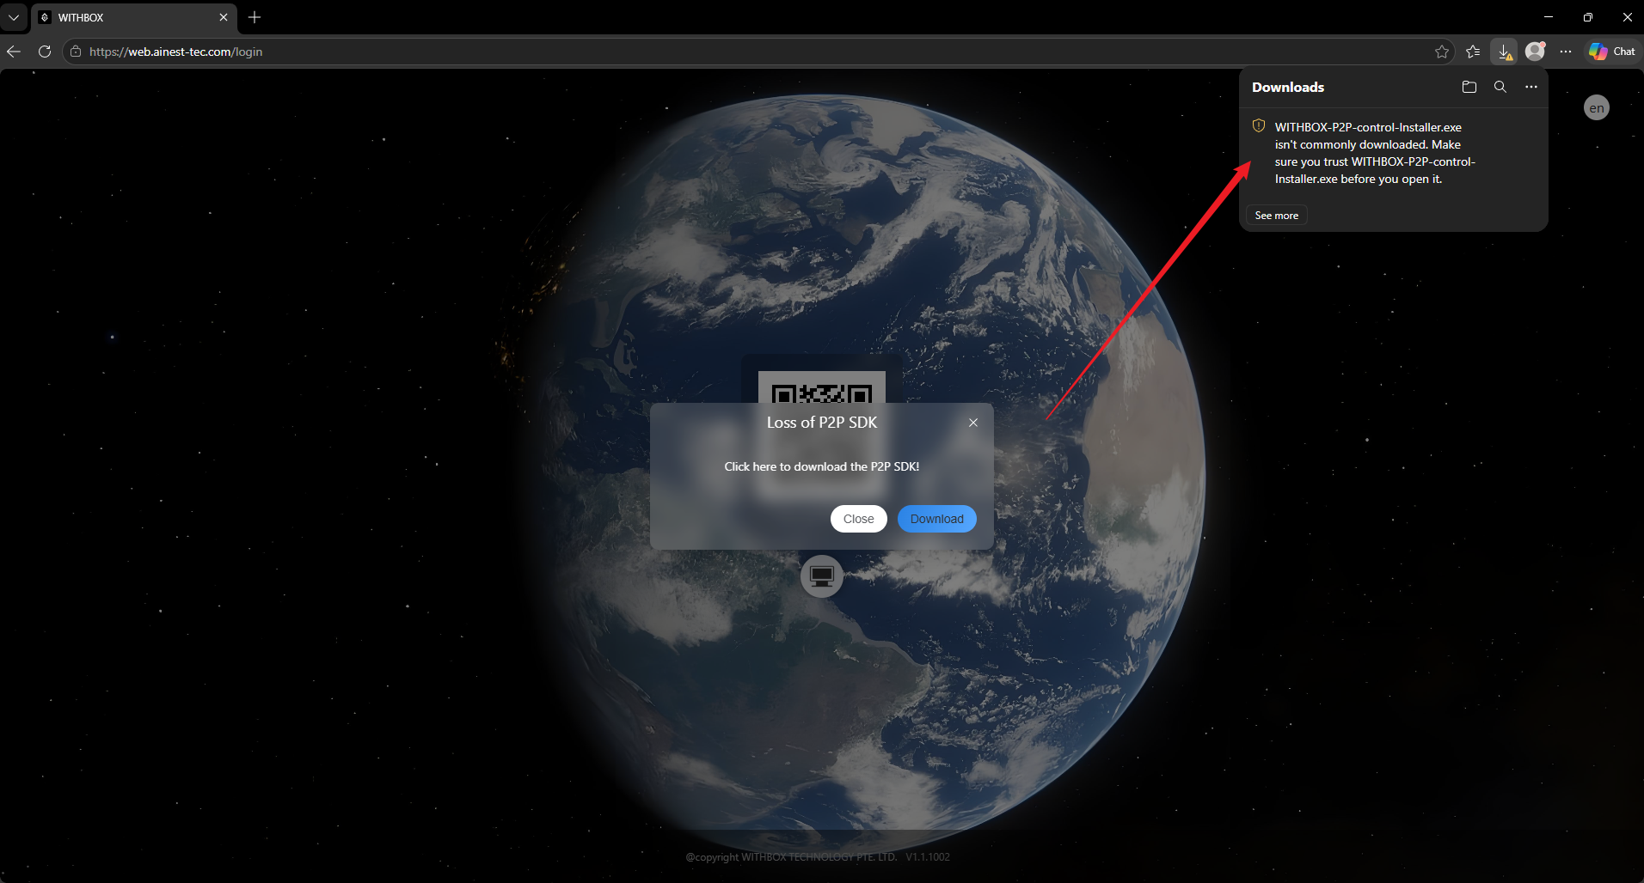
Step 4: Keep clicking Next as prompted by the wizard and wait for the progress to finish. When installation is complete, click Close to exit the installer.
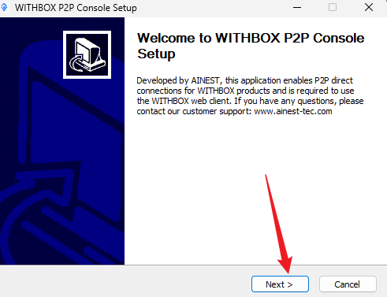
Step 5: Find the plugin icon (WITHBOX P2P Console) on your desktop and double-click it to launch the connection.
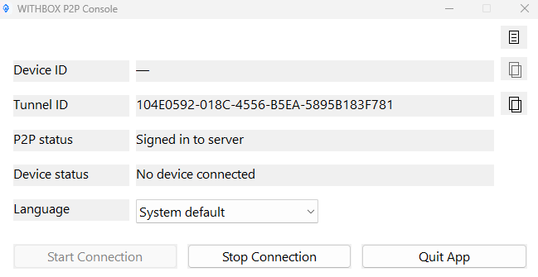

Step 6: Return to the WITHBOX web page and refresh it; the login QR code will appear and the installation is complete.
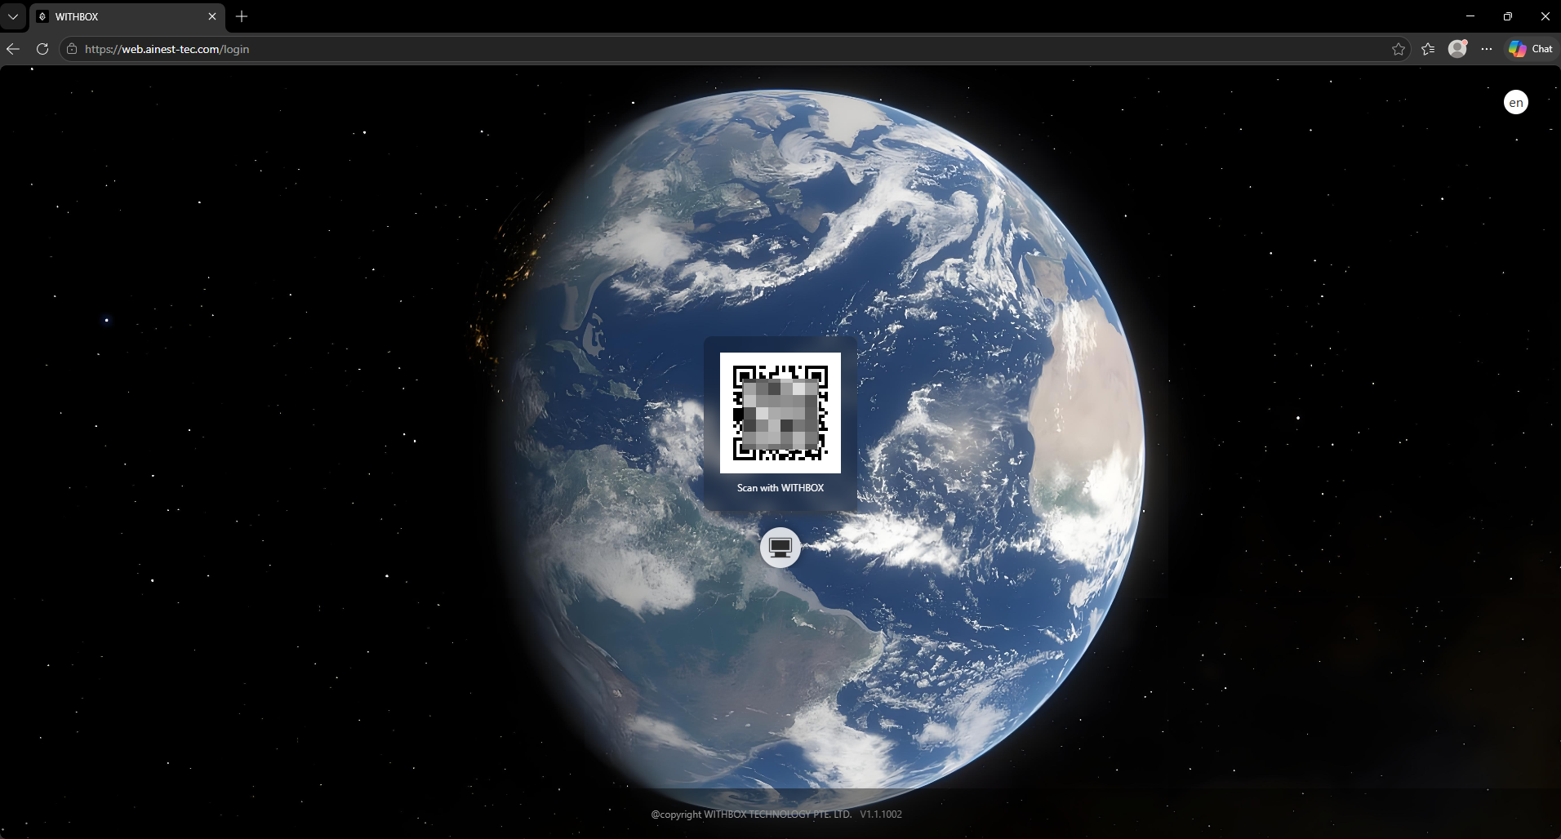

Note: After the plugin is downloaded, a “not commonly downloaded” warning may appear; for any security prompt, choose to allow it to run / keep it.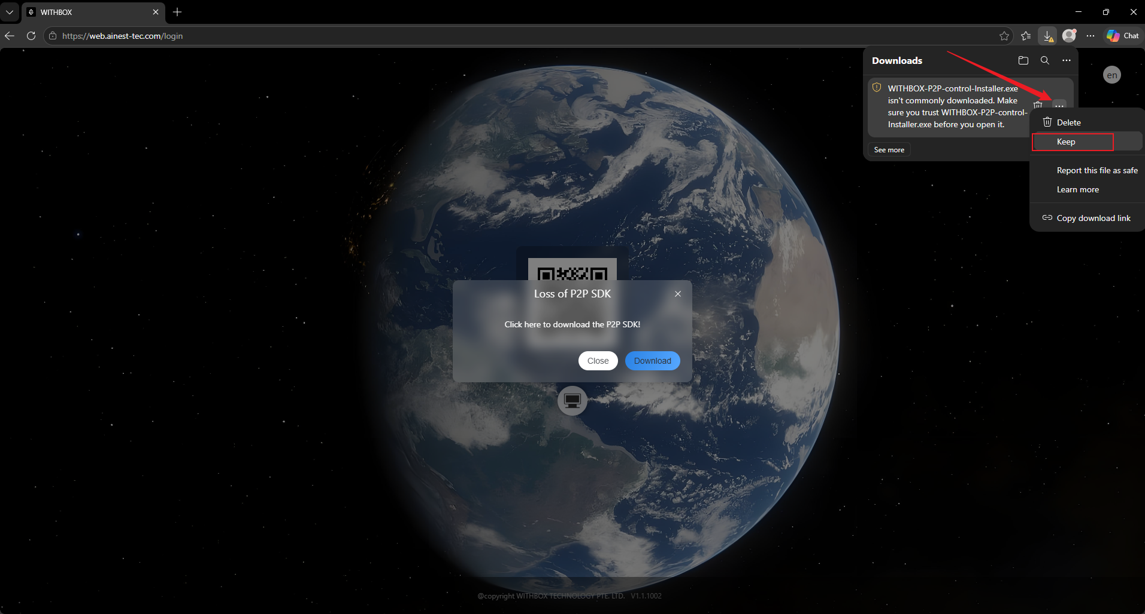
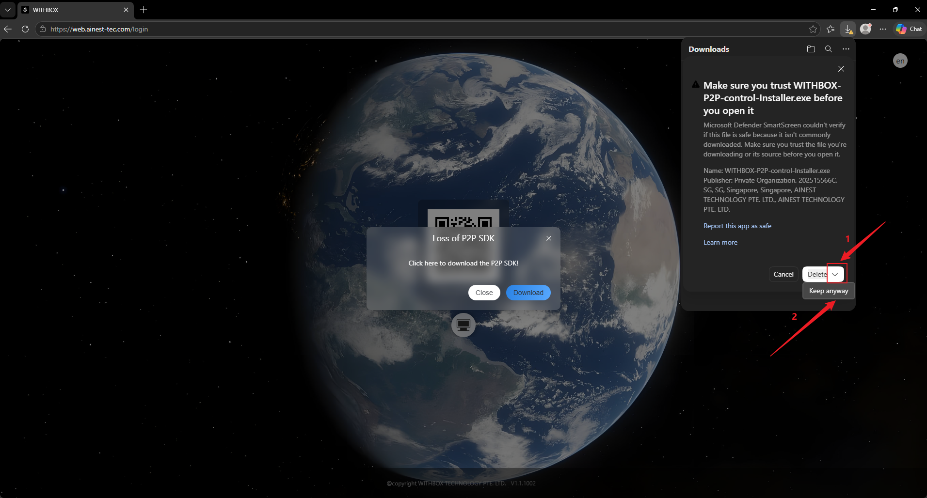

- macOS System:
- Google Chrome Installation Steps
Step 1: Open Google Chrome and visit the WITHBOX official website: web.ainest-tec.com. If the “Connection lost. Reconnecting...” message appears, click logout; if it does not appear, go to Step 2.
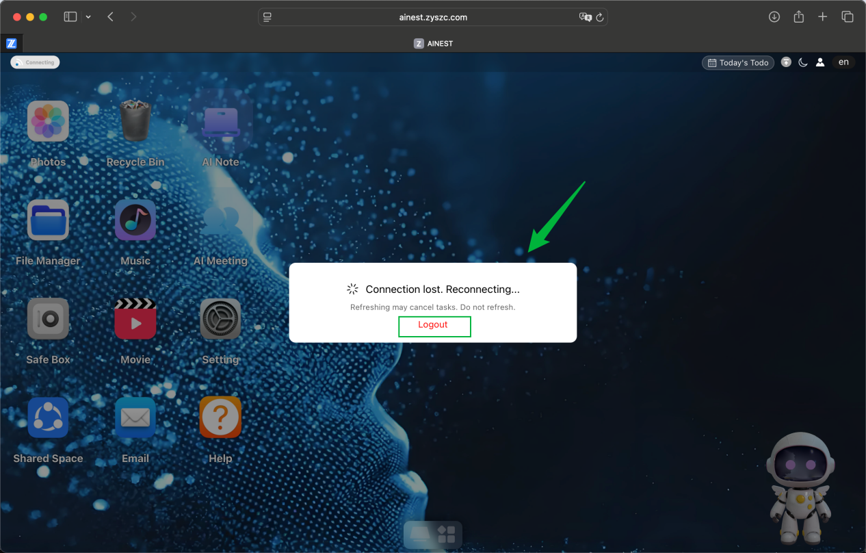
Step 2: An “SDK missing” prompt appears. Click Download in the pop-up to get the P2P SDK installer package (WITHBOX-P2P-control-Installer).
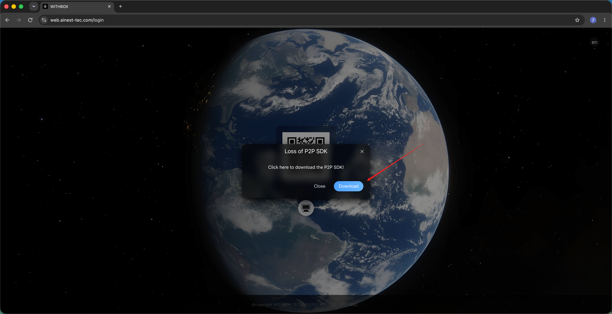
Step 3: After the download completes, click the installer file at the top of the browser or in the download list, then double-click the icon indicated by the arrow to start the installation wizard.
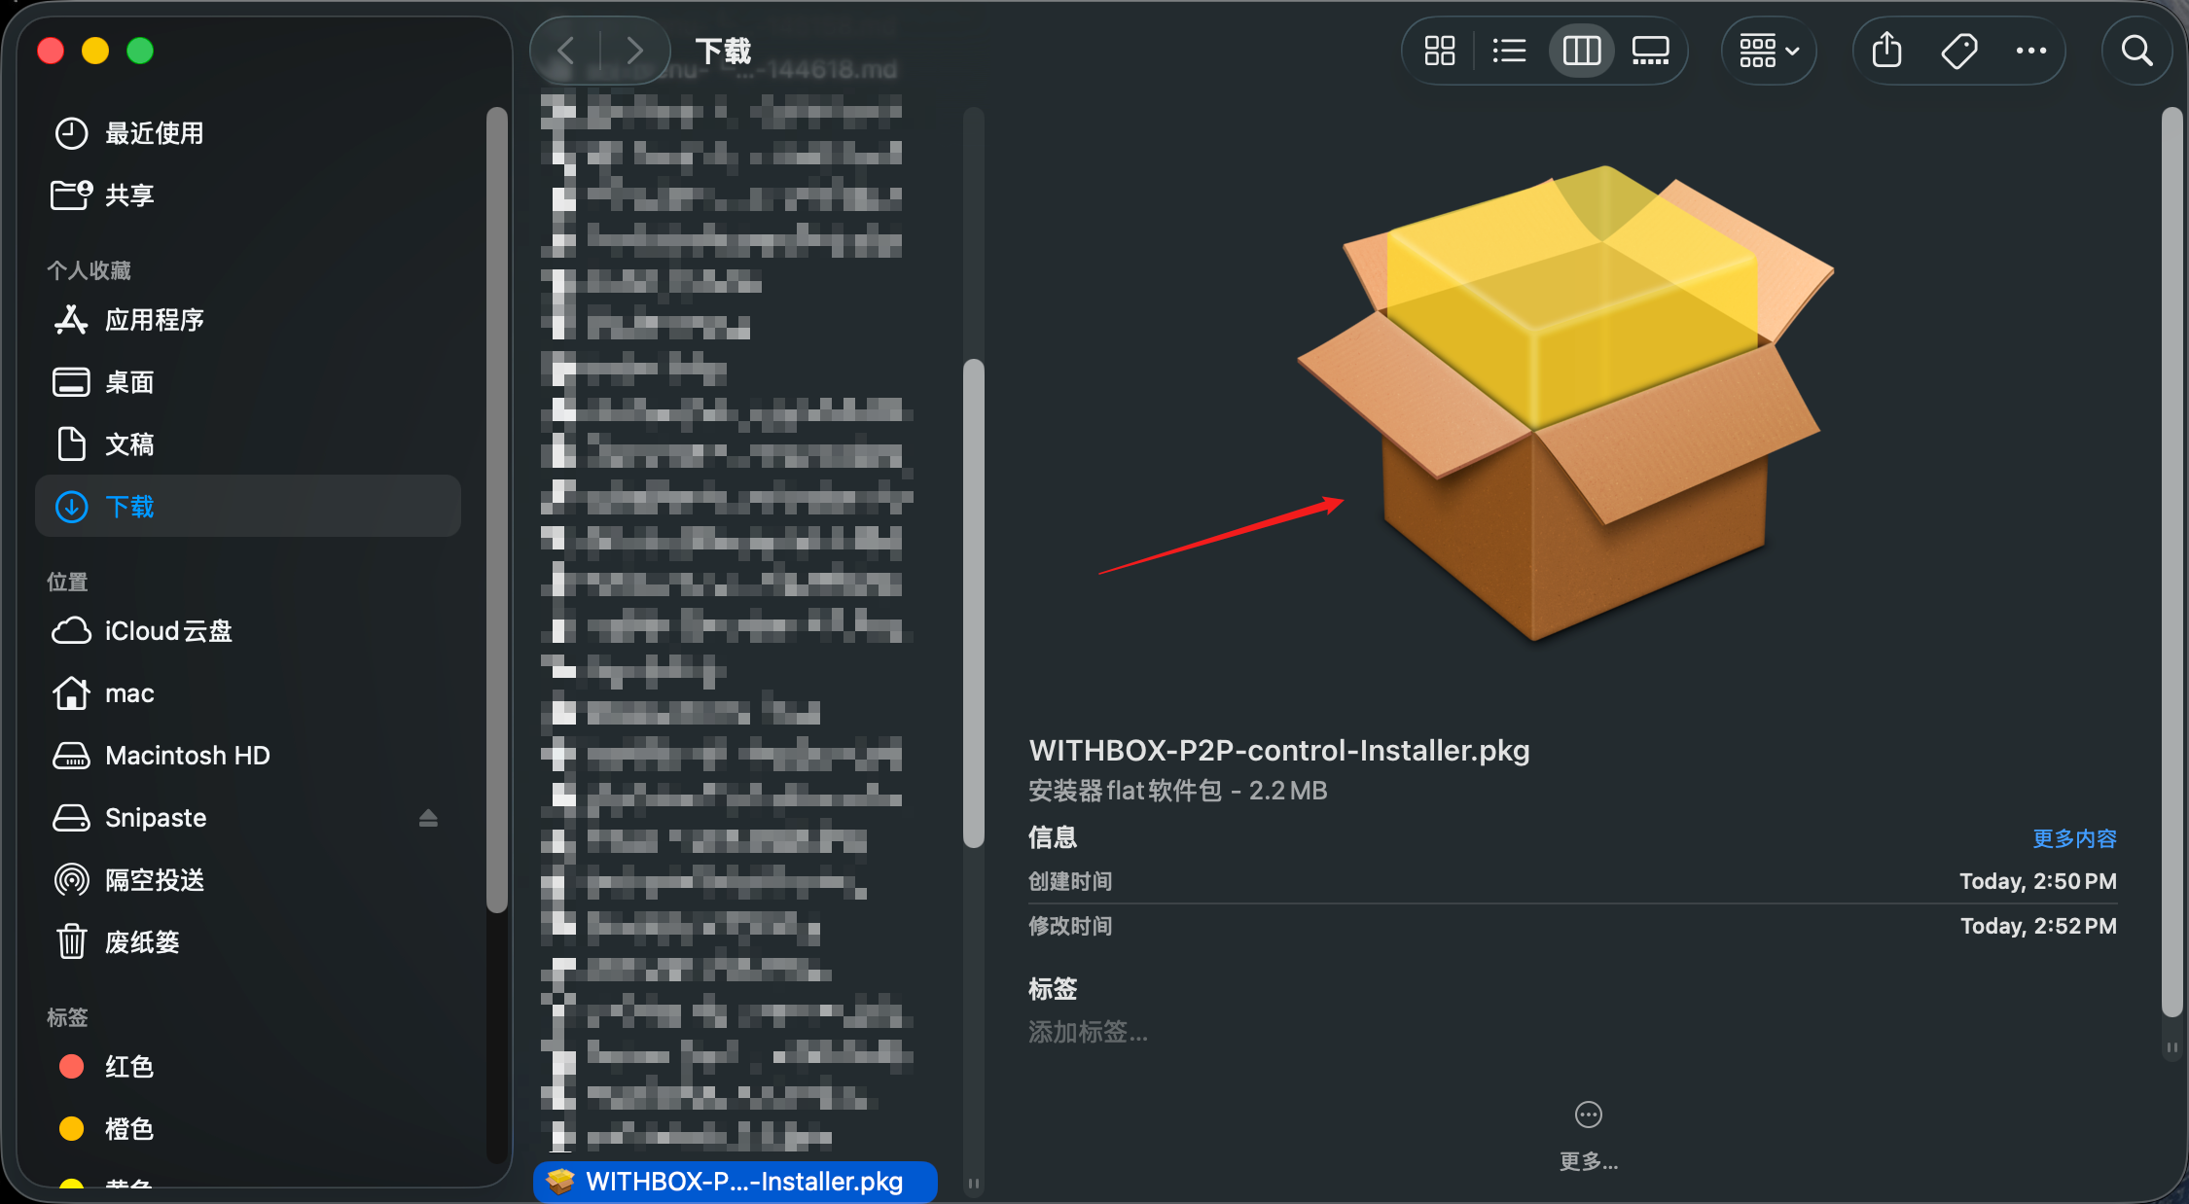
Step 4: Follow the wizard and click “Continue” then “Install”. A warning may appear at this point; click “Allow” and wait for the progress to finish.
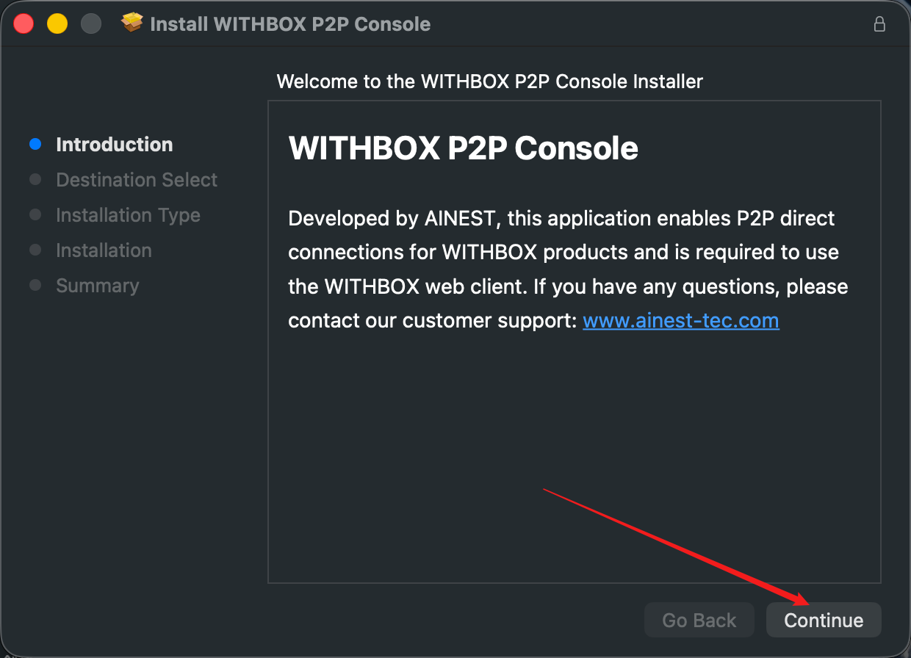
Step 5: After the installation succeeds, click Close to exit the installer.
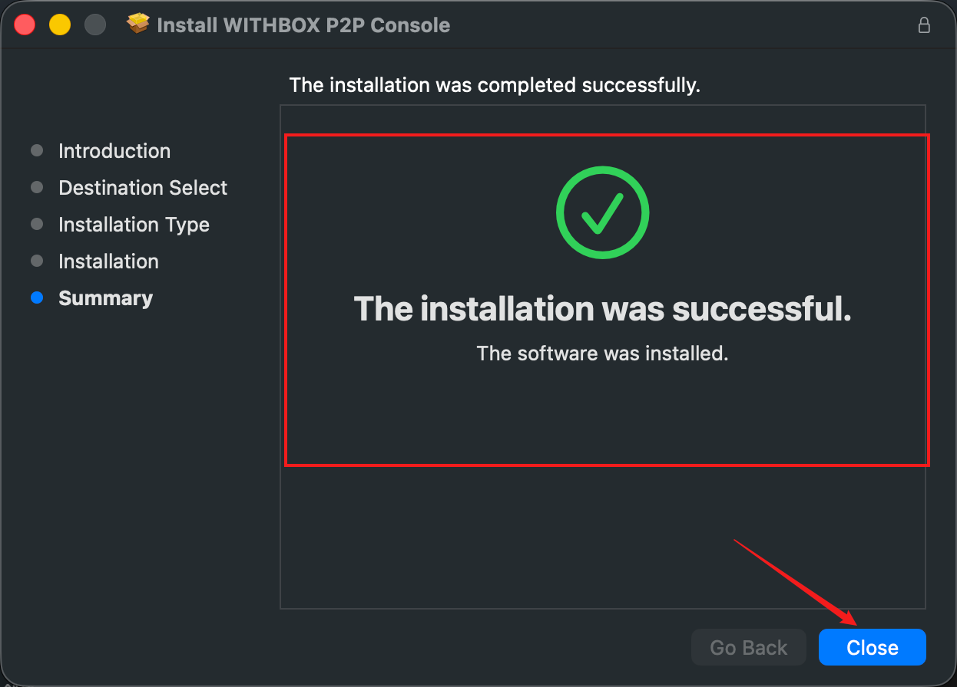
Step 6: A console window like the one below appears on your desktop, showing the connected status. Close or minimize it.
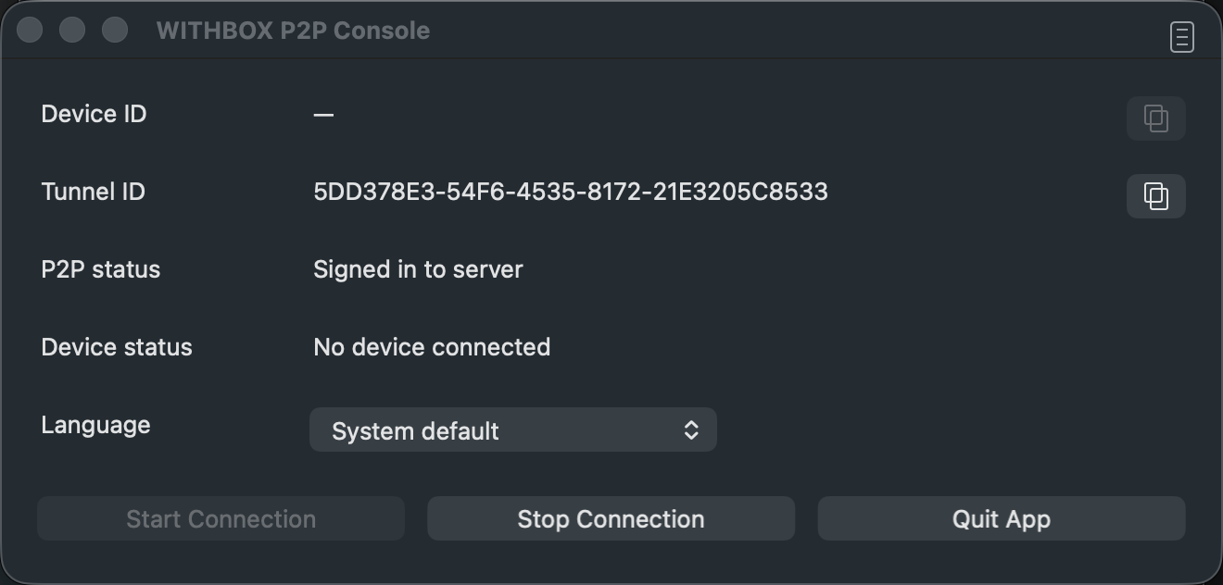
Step 7: Return to the WITHBOX web page and refresh it; the login QR code will appear and the installation is complete.
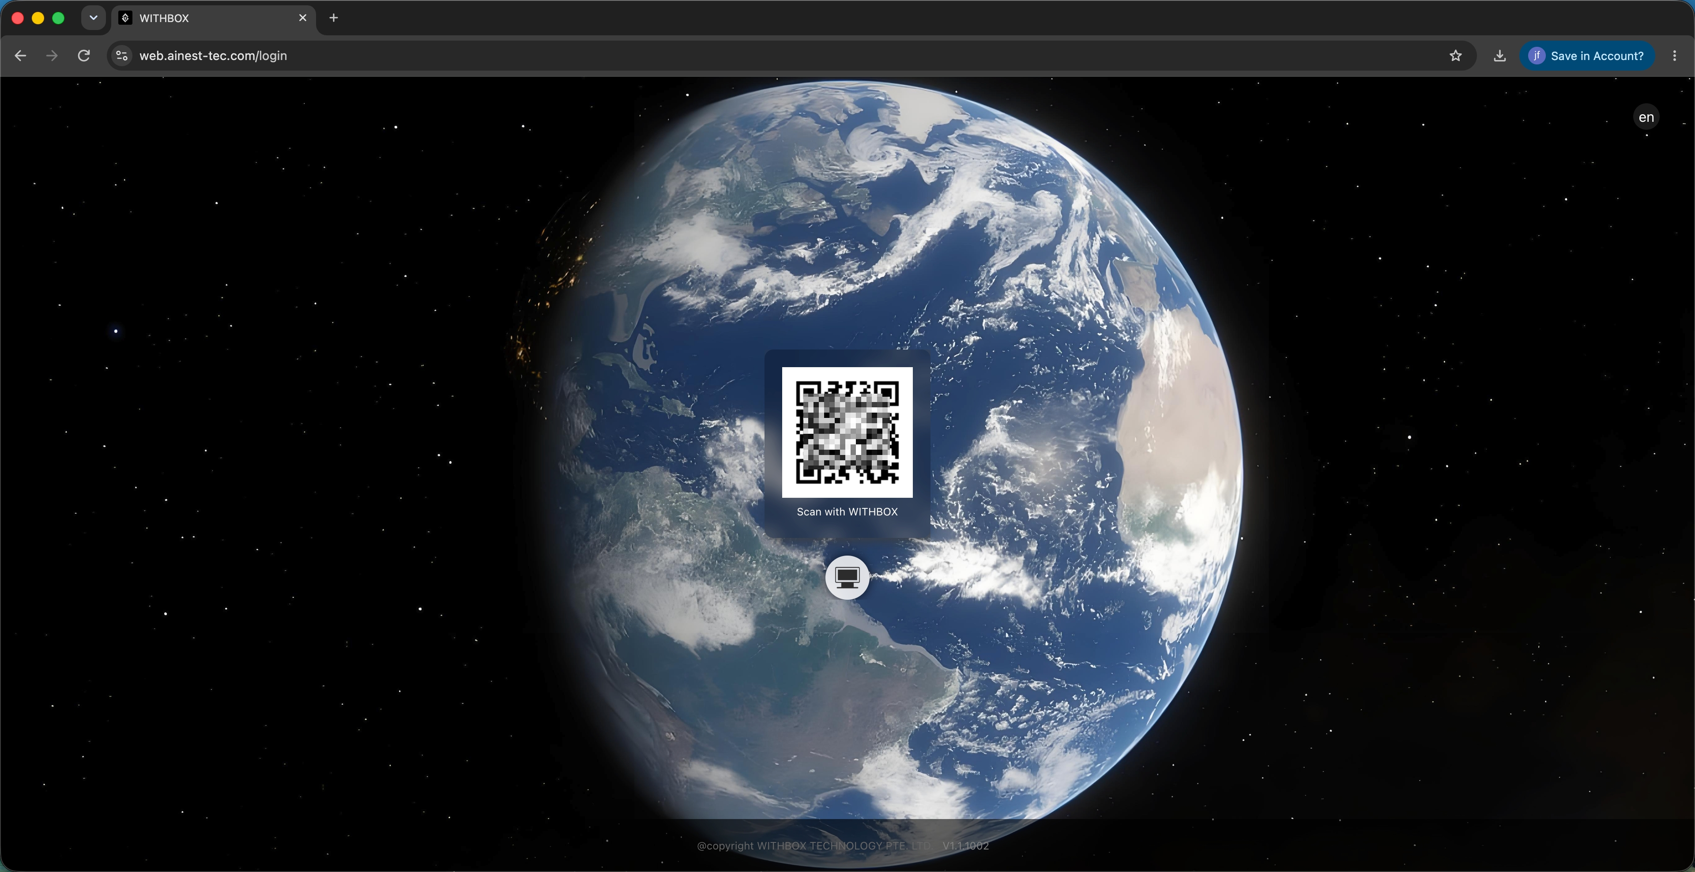
Note: If the “The installer wants to modify the Apps on your Mac” prompt appears during installation, click Allow and enter your Mac login password to authorize it.

