Friday Entry Point on the Web
Step 1: Click the Desktop AI Agent icon on the home page
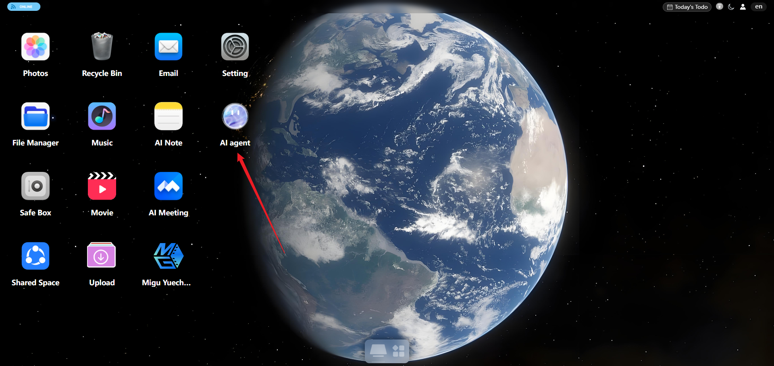
Step 2: The Friday chat window opens and your intelligent journey with Friday begins.
