How to Bind an Email Account on the Web
- Open the app: Click the Mail icon on the desktop to enter the main mail screen.
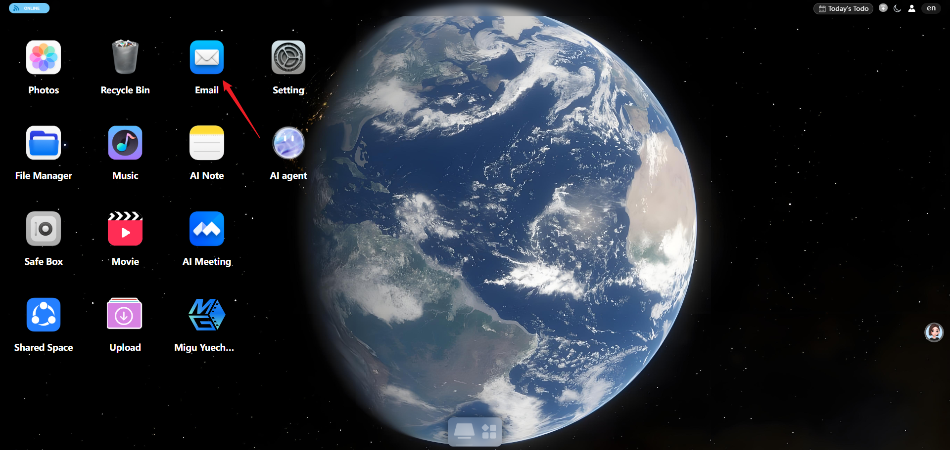
- Click Bind Email or Bind Now
- Bind a QQ Mail account
  - Enter your QQ Mail address (@qq.com)
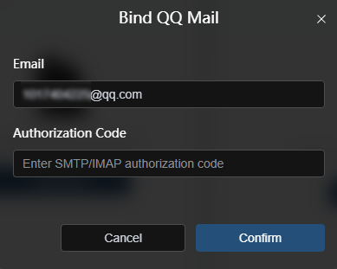
  - Enter the authorization code
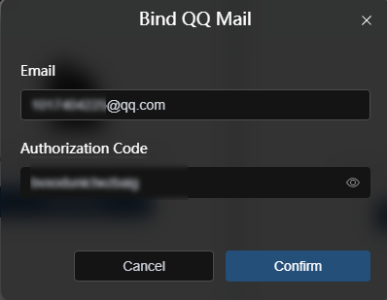
  - You will then enter the mailbox home page
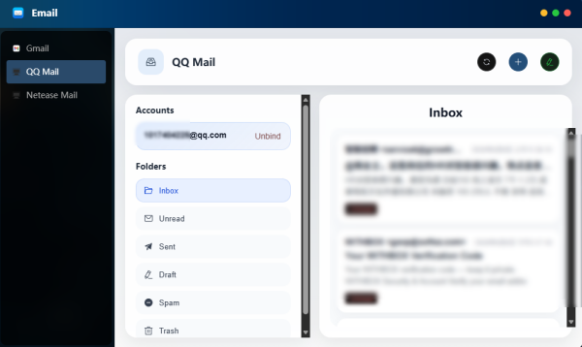
- Bind a NetEase Mail account
  - Enter your NetEase Mail address (@163/126.com)
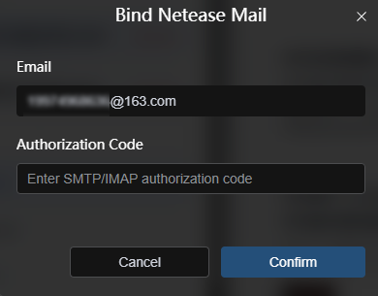
  - Enter the authorization code
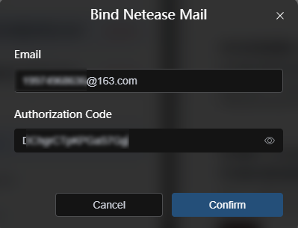
  - You will then enter the mailbox home page
